Project Report Template

#### KIDNEY DISEASE

## INTRODUCTION

The kidneys filter waste and excess fluid from the blood. As kidneys fail, waste builds up.

Symptoms develop slowly and aren't specific to the disease. Some people have no symptoms at all and are diagnosed by a lab test.

Medication helps manage symptoms. In later stages, filtering the blood with a machine (dialysis) or a transplant may be required.

## PROBLEM DEFINITION & DESIGN THINKING

EMPATHY MAP

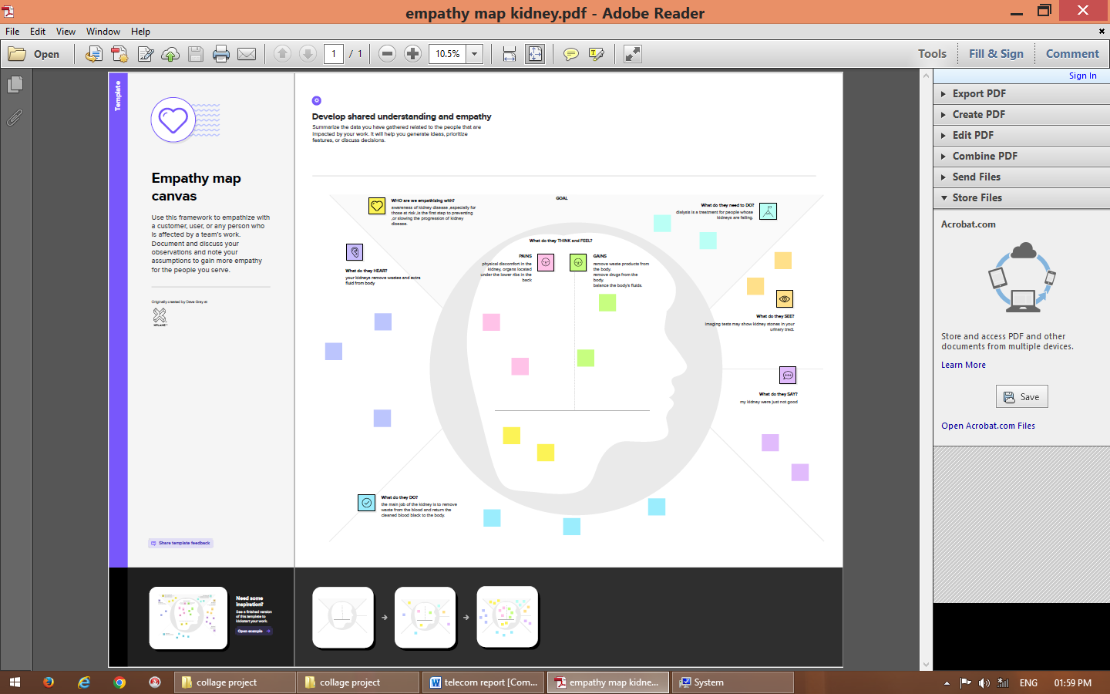

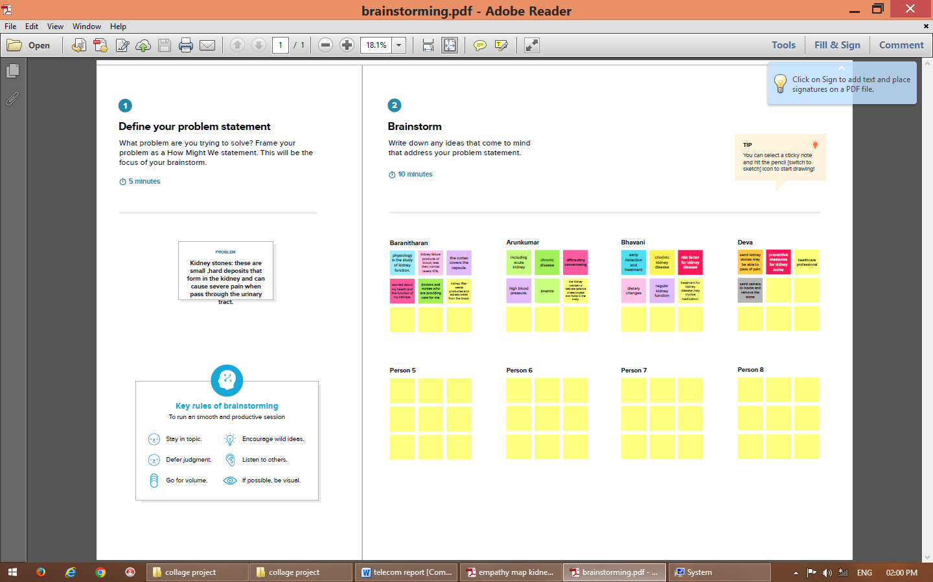

### RESULT

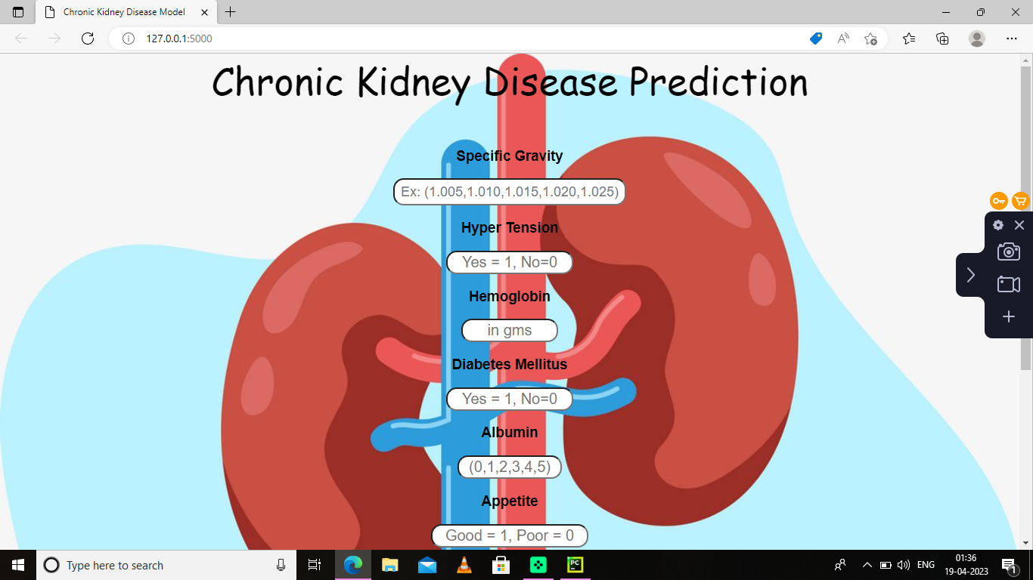

### ADVANTAGES & DISADVANTAGES

Filtering waste product :the kidneys filter out waste product from the blood and eliminate them through urine. This process helps maintain the body’s chemical balance prevents the buildup of harmful toxins.

### DISADVANTAGES

Decreased kidney function: in kidney disease, the kidney are able to filter waste products from the blood effectively, leading to buildup of toxins in the body.

## APPLICATIONS

Kidney disease management apps: these apps allow patients to track their blood pressure , weight, and other vital signs related to kidney disease. They can also help patients keep track of their medications appointments with their healthcare providers.

## CONCLUSION

There are several treatment options available for kidney disease, including medications, life style Changes and kidney transplantation.

## FUTURE SCOPE

Wearable technology: wearable devices that monitor vital signs collect data on kidney function may help patients health care providers better manage kidney disease.

## APPENDIX

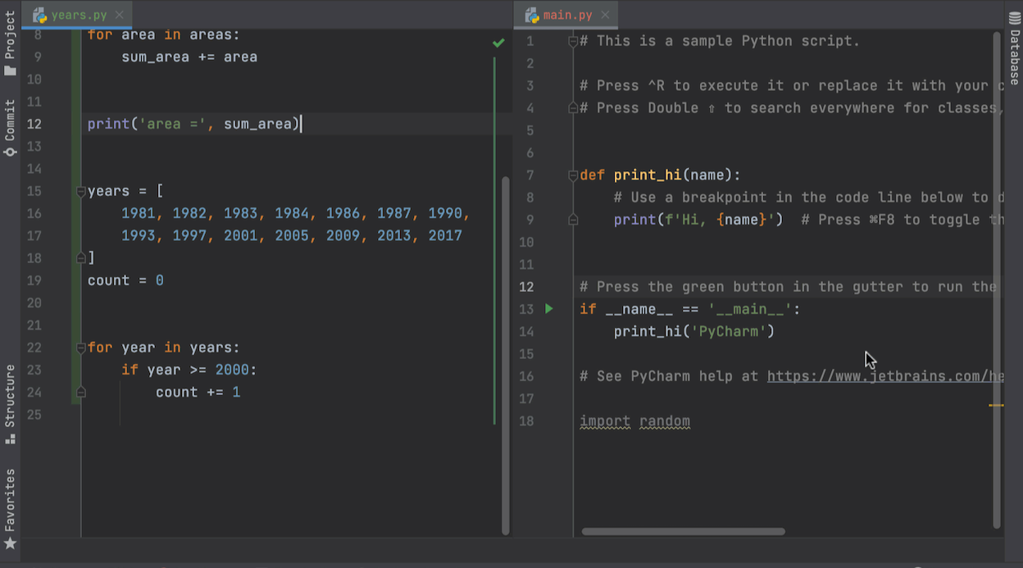

BY

S.Arunkumar

M.Baranitharan

R.Bhavani

D.Deva